- Install Virtual Box
- Install Vagrant(Install VM, Create Shared folder, Create network)
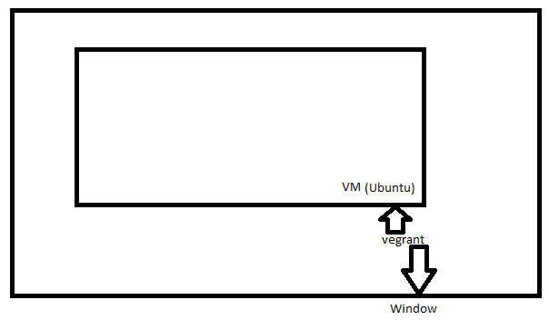
- Perform below task:
  - Create below folder in d drive dev\VM\with-xenial-ubuntu>
  - D:\dev\VM\with-xenial-ubuntu
    - Create sub floder “box” and copy “xenial-server-cloudimg-amd64-vagrant.box”
    - Create folder “machine” and copy “Vagrantfile”
  - install VirtualBox-5.1.4-110228-Win
  - install vagrant_1.9.1
  - install git
- Used below command to check is VM install properly or not.
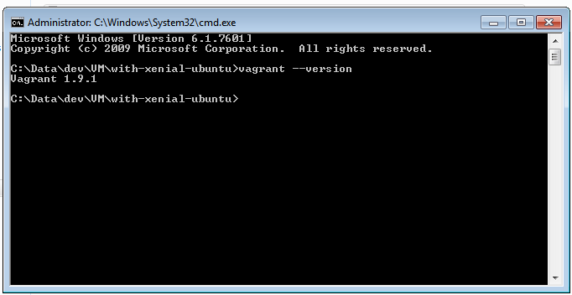
- vagrant box list
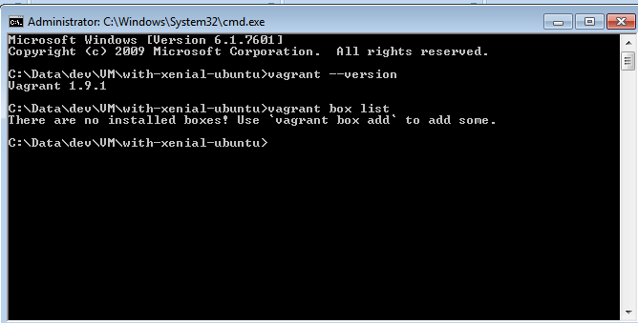

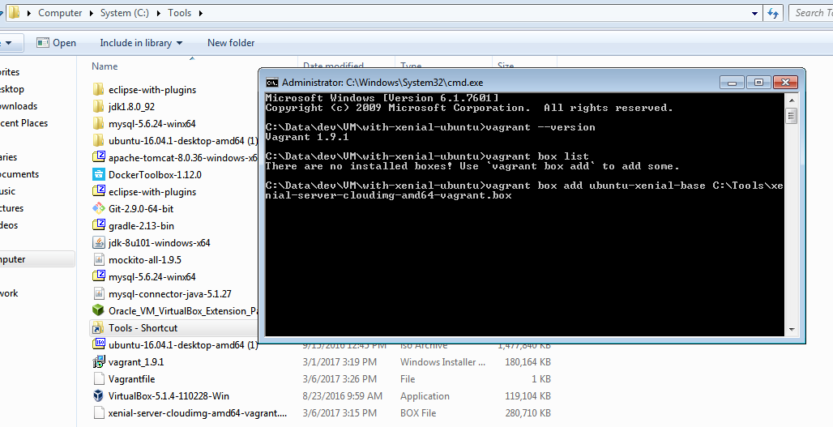

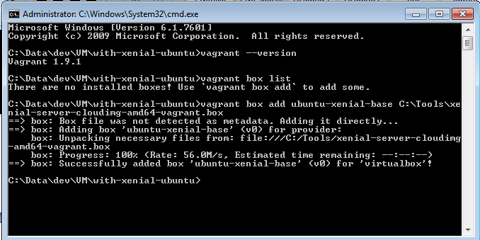
Below command use to start virtual machine
D:\dev\VM\with-xenial-ubuntu\box>vagrant box add ubuntu-xenial-base D:\dev\VM\with-xenial-ubuntu\box\xenial-server-cloudimg-amd64-vagrant.box
C:\Data\dev\VM\with-xenial-ubuntu>vagrant up
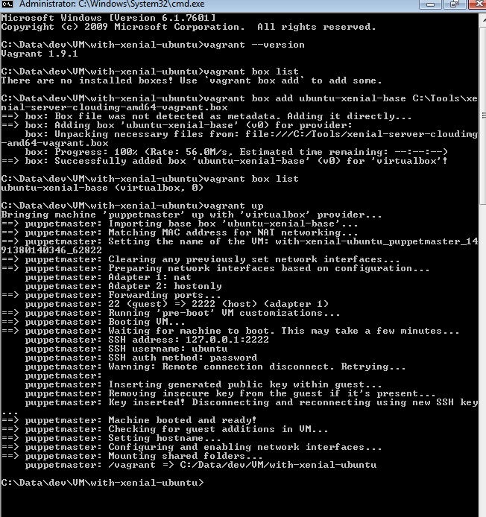
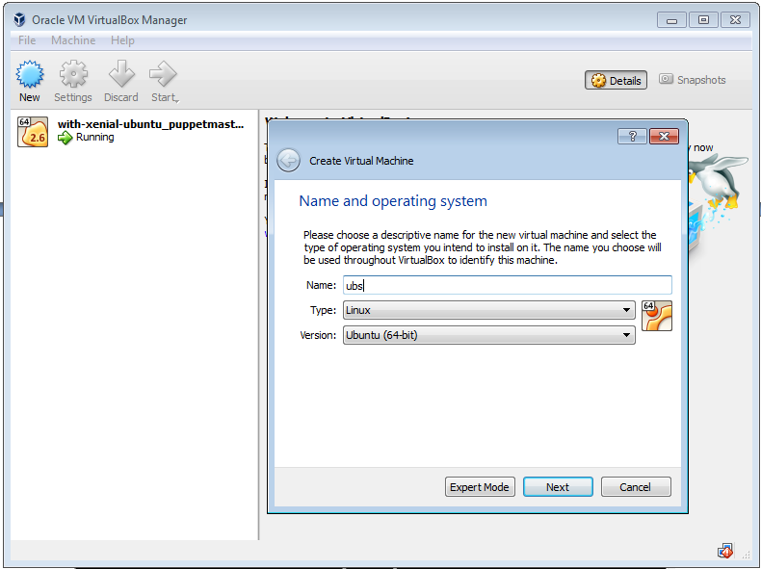
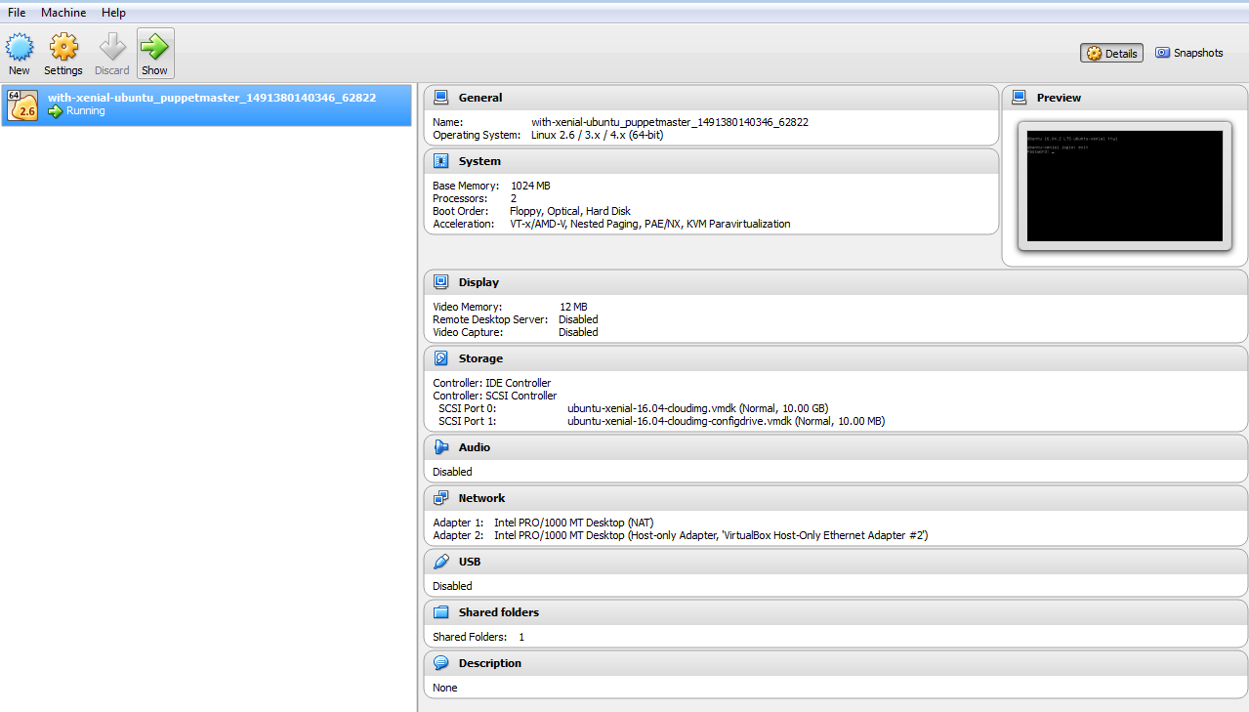
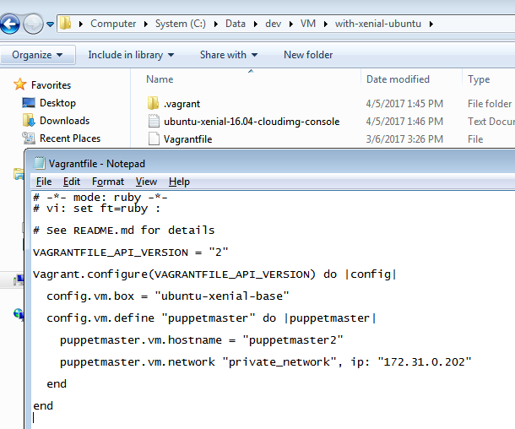
Execute last command
C:\Data\dev\VM\with-xenial-ubuntu>vagrant ssh (used to go to vagrant)
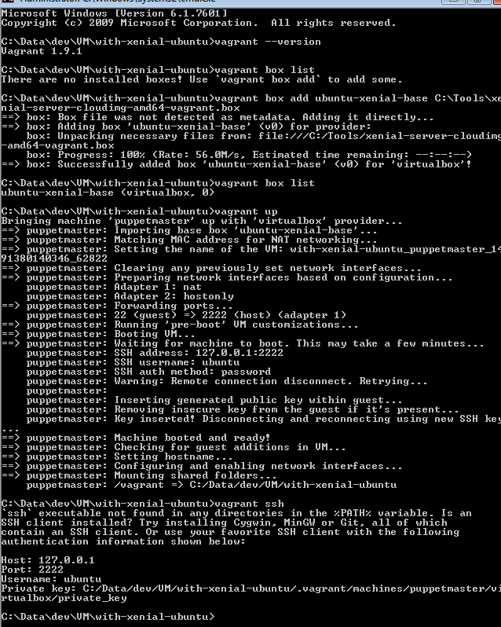
If above error came, Install git and give path till ssh.exe file “C:\Program Files\Git\usr\bin” into environment path
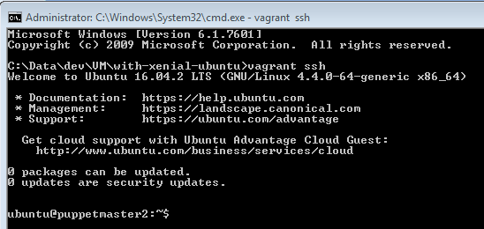
Type below command “sudo su” to get root privilege
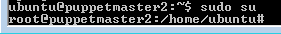
Type below command
apt-get update
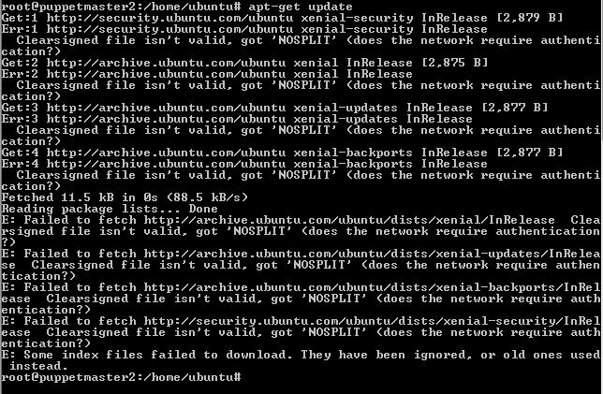
Use below command to check docker install on machine or not
- Docker - – version
Use below command to install docker on system
- apt-get install –y docker.io
if it has “failed to fetch data”
- then go to “cd /etc/apt”
- ls (apt.conf file should not be there)
- nano apt.conf
  - Acquire::http::proxy "http://corp\\<username>:<password>@inpunwbs02-wcg.corp.capgemini.com:8080";
  - Acquire::https::proxy "http://corp\\<username>:<password>@inpunwbs02-wcg.corp.capgemini.com:8080";
  - Ctrl+X
  - Yes
- root@puppetmaster2:~# apt-get update && apt-get install -y docker.io
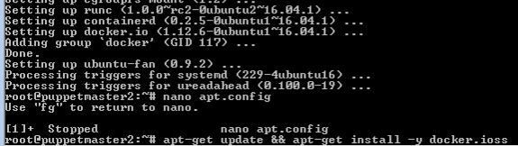
- Docker –version
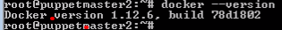

Other Docker related command
- Docker info
- Docker pull hello-world
- Docker run hello-world
- Docker ps

- Create JAVA folder where Vegrantfile is there
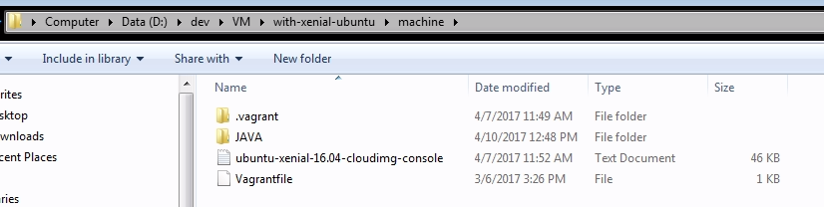

Create folder “D:\dev\VM\with-xenial-ubuntu\machine\JAVA\nexus-repo” and copy project jar/war file
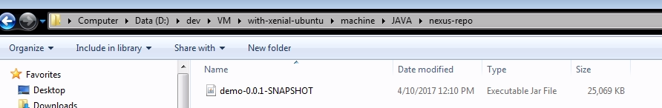

- Create docketfile.txt and paste above content
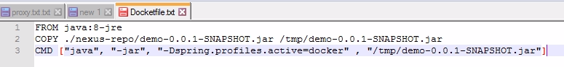
  - FROM java:8-jre
  - COPY ./nexus-repo/demo-0.0.1-SNAPSHOT.jar /tmp/demo-0.0.1-SNAPSHOT.jar
  - CMD ["java", "-jar", "-Dspring.profiles.active=docker" , "/tmp/demo-0.0.1-SNAPSHOT.jar"]

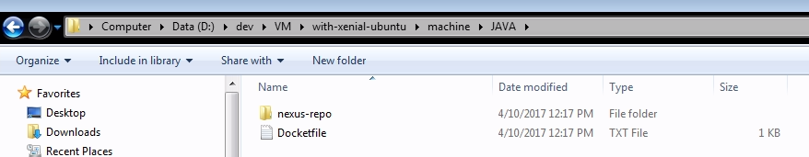
- Rename it docker
D:\dev\VM\with-xenial-ubuntu\machine\JAVA>rename Docketfile.txt docker
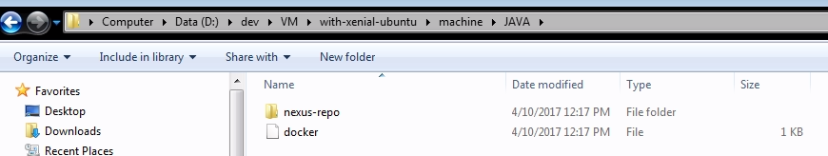

Then go to VM and type below command
cd /vagrant/
ls
cd java
root@puppetmaster2:/vagrant/java# docker build -t ftn/helloworld .

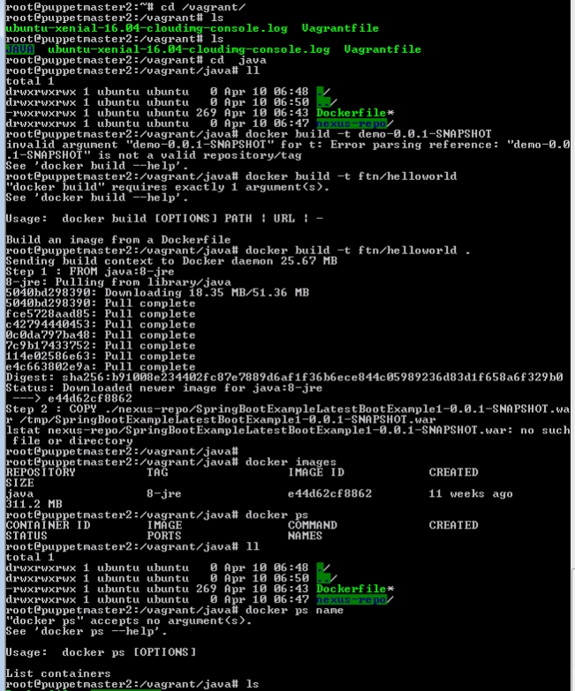

Above image have problem then remove image file
- >Docker rmi-f ftn/helloworld
Then re execute below command
- root@puppetmaster2:/vagrant/java# docker build -t ftn/helloworld . -f docker
- root@puppetmaster2:/vagrant/java# docker run -d -p 8080:8080 ftn/helloworld
- root@puppetmaster2:/vagrant/java# docker ps
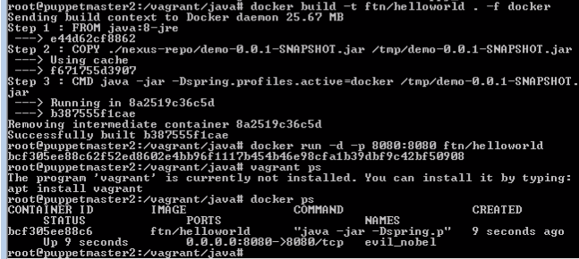

After execute above step check ip address of above application by executing above command
- root@puppetmaster2:/vagrant/java# ifconfig
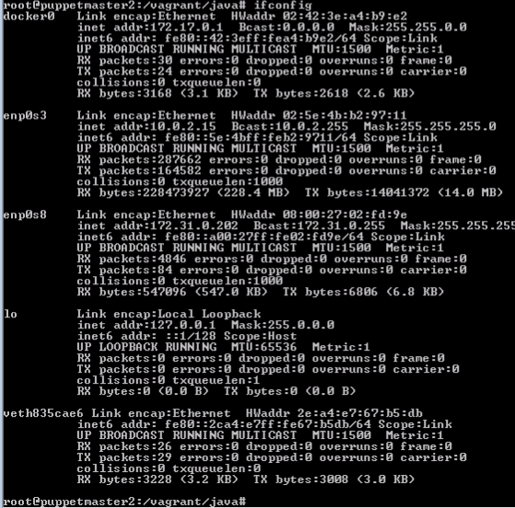
Use below url to access application
- http://172.31.0.202:8080/hello-world?name=sandesh
